Source - https://www.springboottutorial.com/spring-boot-unit-testing-and-mocking-with-mockito-and-junit
https://medium.com/thefreshwrites/junit-and-mockito-in-spring-boot-38dcbf4b132f
https://www.youtube.com/watch?v=SvSr8bK6F94
https://www.youtube.com/watch?v=KYkEMuA50yE&t=3264s&sttick=0
https://www.youtube.com/watch?v=aNCPy803rkI
https://www.youtube.com/watch?v=jN6coBcCcOk
https://www.youtube.com/watch?v=YcAC59cvcV0
https://github.com/KunalN25/junit-testing-tutorial/blob/master/src/test/java/MockingTests.java

Main source - https://www.freecodecamp.org/news/java-unit-testing/
https://www.javaguides.net/2023/10/mockito-annotations-with-examples.html

https://devwithus.com/java-spring-mock-repository/

Unit Testing involves testing each and every component of your code to see if they work as expected..

Do's and Don'ts of Unit Testing
Remember the following guidelines while writing tests for your methods:
- Do test if the expected output of a method matches the actual one.
- Do test whether the function calls made inside the method are occurring the desired number of times.
- Do not try to test code that is not a part of the method under test.
- Do not make API calls, database connections, or network requests while writing your tests.

Assertions
Assertions determine whether your test passes or fails. They compare the expected return value of a method with the actual one. There are a number of assertions you can make at the end of your test.
The Assertions class in JUnit consists of static methods that provide various conditions deciding whether the test passes or not.

Mocking
The class whose methods you are testing may have some external dependencies. As mentioned before, you should not try to test code that is not part of the function under test.
But in cases where your function uses an external class, it is a good practice to mock that class – that is, have mock values instead of the actual ones. We'll use the Mockito library for this purpose.

Method Stubbing
External dependencies may not be limited to just classes, but to certain methods as well. Method stubbing should be done when your function is calling an external function in its code. In this case, you make that function return the value you want instead of calling the actual method.
For instance, the method you're testing (A) is calling an external method (B) in its implementation. B makes a database query, fetching all students with marks greater than 80. Making an actual database call isn't a good practice here. So, you stub the method and make it return a dummy list of students you need for testing.

Steps to Perform While Testing
- Initialize the necessary parameters you'll need to perform the test.
- Create mock objects and stub any methods if required.
- Call the method you are testing with the parameters you initialized in Step 1.
- Add an assertion to check the outcome of your test. This will decide if the test passes.
You'll understand these steps more with examples. Let's start with a basic test first.

How to Write the First Test
Let's write a simple function that compares two numbers. It returns 1 if the first number is greater than the second and returns -1 otherwise.
We'll put this function inside a Basics class:
public class Basics {
public int compare(int n1, int n2) {
if (n1 > n2) return 1;
return -1;
}
}
Let's write the test for this class. All your tests should be located inside the test folder.
Unit tests are basically a set of methods you define that test each method of your class.
@Test
@DisplayName("First number is greater than second")
public void compare()
{
Basics basicTests = new Basics();
int value = basicTests.compare(2, 1);
Assertions.assertEquals(1, value);
}

The @Test annotation indicates that this method is to be run as a test case.
Now, to test the method, you need to create the object of the above class and call the method by passing some values.
Now, use the assertEquals() method of the Assertions class to check if the expected value matches the expected one.
Our test should pass, as the value returned by the method matches the expected one.

How to Create Mocks and Stubs for Testing
We have seen a few basic examples of unit tests where you made simple assertions. However, the functions you are testing may contain external dependencies like model classes and database or network connections.
Now, you can't make actual connections in your tests, as it would be very time consuming. In such cases, you mock such implementations. Let's see a few examples of mocking.

Mocking a Class
Let's have a class User with the following properties:
public class User {
private String username;
private String password;
private String role;
private List<String> posts;
}
Click on ⌘ + N to generate getters and setters for the above properties.
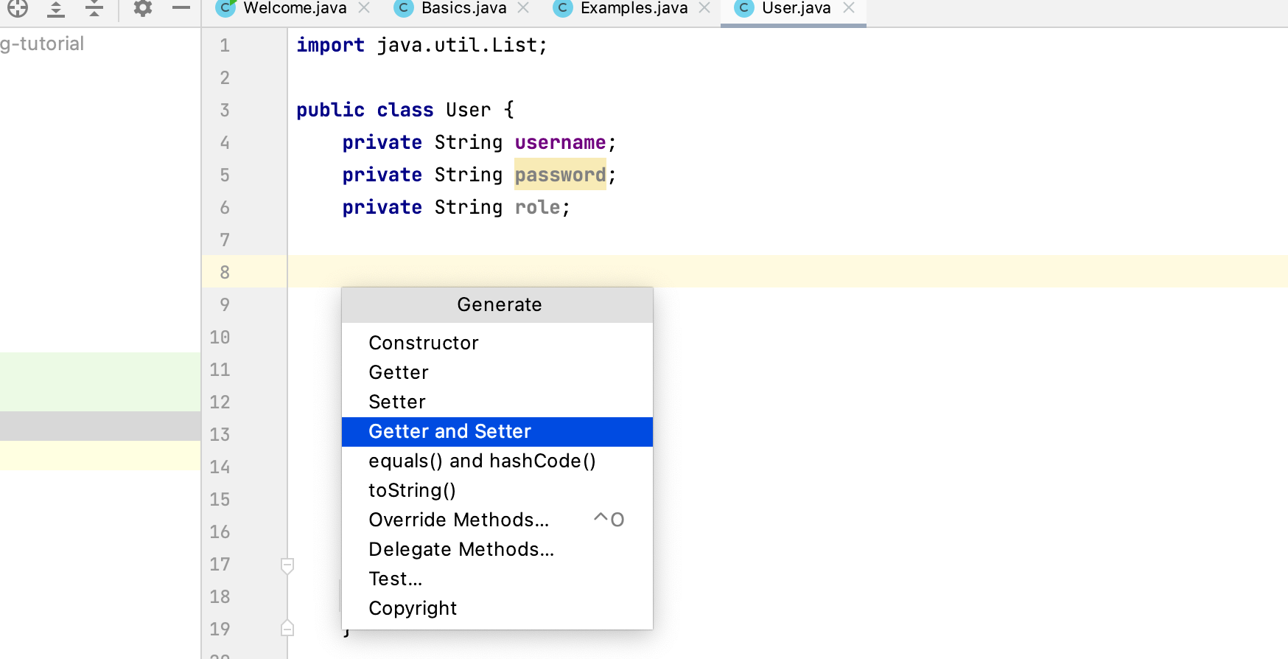
Let's take a new class Mocking that uses the above object.
public class Mocking {
User user;

public void setUser(User user) {
this.user = user;
}
}
This class has a method that assigns certain permissions based on the user's role. It returns 1 if the permission is assigned successfully, else it returns -1.
public int assignPermission() {
if(user.getRole().equals("admin")) {
String username = user.getUsername();
System.out.println("Assign special permissions for user " + username);
return 1;
} else {
System.out.println("Cannot assign permission");
return -1;
}
}
In the tests file, we'll add an @ExtendWith annotation at the top since we are using Mockito. I have not shown the imports here as IntelliJ does them automatically.
@ExtendWith(MockitoExtension.class)
public class MockingTests {

}
So how do we write the test for the method? We'll need to mock the User object. You can do this by adding a @Mock annotation while declaring the object.
@Mock
User user;
You can also use the mock() method, as it's similar.
User user = mock(User.class);
Let's write the test method.
@Test
@DisplayName("Permission assigned successfully")
public void assignPermissions() {
Mocking mocking = new Mocking();
Assertions.assertEquals(1, mocking.assignPermission());
}
When you run the test, it throws a NullPointerException.
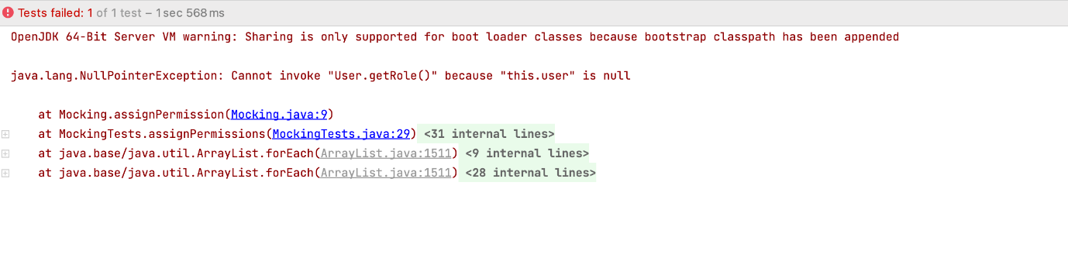User Object is Null
This is because the user object hasn't been initialised yet. The method you called wasn't able to use the mocked object. For this, you'll need to call the setUser method.

mocking.setUser(user);

Now, the test gives the following error as the mocked object is initially filled with null values.
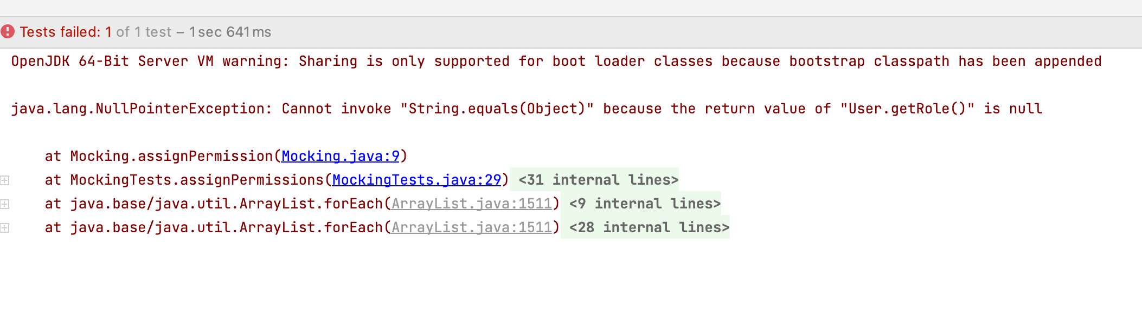Return Value of getRole() is Null
Does this mean you need to fill actual values in the mock object? No, you just need the getRole() method to return a non-null value. For that, we'll use method stubbing.

when(user.getRole()).thenReturn("admin");

Using when()...thenReturn() tells the test to return a value when a method is called. You should stub methods only for mocked objects.
We'll do the same for the getUsername() method.

when(user.getUsername()).thenReturn("kunal");

Now, if you run the test, it will pass.
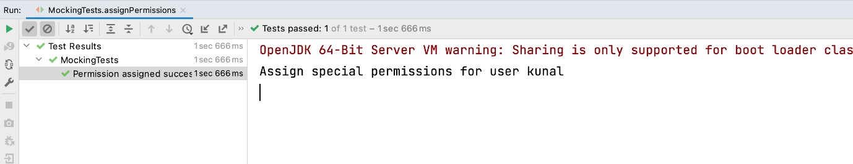Test Passed

Method Stubbing Example
In the above example, I simply stubbed getter methods to demonstrate method stubbing. Instead of stubbing getters, you could set the role and username with a parameterised constructor or setter methods if they are available.
user.setRole("admin");
user.setUsername("kunal");
But what if the user class has a method that returns all the posts containing a certain word in them?
public List<String> getAllPostsContainingWord(String word) {
List<String> filteredPosts = new ArrayList<>();
for(String post: posts) {
if(post.contains(word))
filteredPosts.add(post);
}
return filteredPosts;
}
We want this method to return all posts containing the word "awesome". If you call the actual implementation of this method, it might take a long time as the number of posts could be huge. Also, if you are mocking the User object, the posts array would be null.
In this case, you stub the method and make it return the list you want.
List<String> filteredPosts = new ArrayList<>();
filteredPosts.add("Awesome Day");
filteredPosts.add("This place is awesome");
when(user.getAllPostsContainingWord("awesome")).thenReturn(filteredPosts);

Method Stubbing in Database Queries
Let's see how to test methods that involve making database connections. First, create a class ApplicationDao that contains all the methods performing database queries.
public class ApplicationDao { }
Define a method that fetches the user by id and returns null if the user is not found.
public User getUserById(String id) {
// Make database query here
}
Create another method to save a user into the database. This method throws an exception if the user object you are trying to save is null.
public void save(User user) throws Exception {
// Make database query here
}
Our Mocking class will use these methods to implement its own functionalities. We'll implement one function that updates the name of a user.
public int updateUsername(String id, String username) throws Exception{
ApplicationDao applicationDao = new ApplicationDao();
User user = applicationDao.getUserById(id);
if(user!=null)
user.setUsername(username);
applicationDao.save(user);
return 1;
}
The method implementation is pretty straightforward. First, get the user by id, change its username and save the updated user object. We'll write the test cases for this method.
There are two cases we need to test. The first is when the user is updated successfully. The second is when the update fails, that is when an exception is thrown.
Before writing the tests, create a mock of the ApplicationDao object as we do not want to make actual database connections.
@Mock
ApplicationDao applicationDao;
Let's write our first test.
@Test
@DisplayName("User updated successfully")
public void updateUsername() throws Exception {
...
}
Create a user object for testing.
User user = new User();
user.setUsername("kunal");
Since we are calling an external method, let's stub the method so that it returns the above User object.
when(applicationDao.getUserById(Mockito.anyString())).thenReturn(user);
Pass Mockito.anyString() to the method as we want the stub to work for any string parameter. Now, add an assertion to check if the method is working correctly.
Assertions.assertEquals(1, mocking.updateUsername("3211", "allan"));
The method returns 1 on successful update, so the test passes.
Now, let's test another scenario where the method fails and throws an exception. Simulate this scenario by making the method getUserById() return null.
lenient().when(applicationDao.getUserById(Mockito.anyString())).thenReturn(null);
This value is then passed to the save() method which in turn throws an exception. In our assertion, we'll use assertThrows() method to test whether an exception was thrown. This method takes the type of the exception and a lambda expression as parameters.
Assertions.assertThrows(Exception.class, () -> {
mocking.updateUsername("3412","allan");
});
Since the exception is thrown, our test passes.
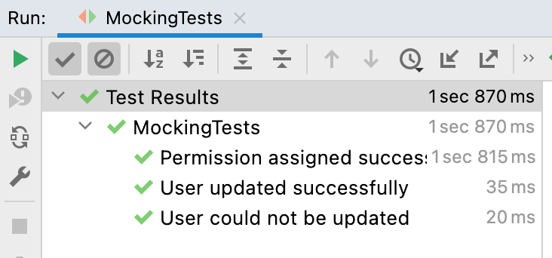Tests Passed
Mockito means cloning objects for testing and using dummy objects for testing
request will not go to db for testing.
Mockito uses java Refelection in order to create objects for a given interface.

It’s a mocking framework and it is java -based library for unit testing of java applications.

Consider you are writing a Rest API, so for each of the APIs, we can write the test cases and test in the application before committing to our main API. In unit testing, we will mock the services, which means we will not call the database every time instead we will use the mockup data.
Mockito internally uses the Java reflection API to generate the mock objects. The main purpose of using the Mockito framework is to simplify development by mocking the external dependencies and using them in the test code. We can also use Mockito with other testing frameworks like JUnit and TestNG.

@InjectMocks vs @Mock
@Mock creates a mock. @InjectMocks creates an instance of the class and injects the mocks that are created with the @Mock (or @Spy) annotations into this instance
initialize these mocks and inject them With JUnit 5, you must use @ExtendWith(MockitoExtension.class).

@BeforeEach annotation in JUnit 5 is used to mark a method that should execute before each test method in the JUnit test case. It is used to provide initialization for set-up tasks.

Mock Repository using Mockito
Mockito comes with a host of ready-to-use methods and annotations to do all the heavy lifting of mocking objects.
In short, Mockito offers two ways to create a mock for a repository:
- @Mock annotation
- Static method mock()
So, let’s take a close look at each option.

Using @Mock
Now, let’s move on to the unit test. First, we will be using the @Mock annotation to mock StudentRepository.

@ExtendWith(MockitoExtension.class)
class StudentServiceUnitTest {
@Mock
private StudentRepository studentRepository;
@InjectMocks
private StudentServiceImpl studentService;
}

- @ExtendWith(MockitoExtension.class) enables Mockito support
- @InjectMocks allows to create studentService and inject the mocked studentRepository into it
For instance, let’s add a test case to test the findAll() method:

@Test
void findAll_should_return_student_list() {
// Given
Student student = new Student();
student.setId(1);
student.setFirstName("Abderrahim");
student.setLastName("Azhrioun");
student.setAge(20);
student.setGender("Male");

// When calling the mocked repository method
when(studentRepository.findAll()).thenReturn(List.of(student));
List students = this.studentService.findAll();

// Then
assertEquals(List.of(student), students);
verify(this.studentRepository).findAll();
}

Another solution would be using MockitoAnnotations.initMocks(this) to initialize the annotated mocked objects. However, this method is marked as deprecated.

Using Mockito.mock()
Now let’s go ahead and see how we can use the Mockito.mock() method to achieve the same objective:

class StudentServiceUnitTestV2 {
private StudentRepository studentRepository;
private StudentServiceImpl studentService;

@BeforeEach
void setup() {
studentRepository = Mockito.mock(StudentRepository.class);
studentService = new StudentServiceImpl(studentRepository);
}
}

The method takes the class of the object to mock as a parameter. This is why we passed StudentRepository.class.

Mocking Repository that Returns Optional
Typically, findById() returns an Optional object unlike findAll() which return a simple list.
So, how we can tell the mocked repository to return an Optional when invoking findById()?
To answer this question, we are going to create a test case:

@Test
void findById_should_return_single_student() {
// Given
Student student = new Student();
student.setId(2);
student.setFirstName("Emma");
student.setGender("Female");

// When calling findById returns Optional
when(studentRepository.findById(anyInt())).thenReturn(Optional.of(student));
Optional<Student> returnedStudent = this.studentService.findById(2);

// Then
assertTrue(returnedStudent.isPresent());
verify(this.studentRepository).findById(2);
}

Please notice that we used Optional.of(student) to tell thenReturn() to return an Optional when findById() is called.

